Rowing

The main sources for this material were Randall Crawford, Jennifer Cunningham, Dan McLaughlin, the booklet, Bann Rowing Club 1842-1937 (published in 1938 by Coleraine Chronicle), and the Gribbon family.

The Coleraine Rowing Club was established in 1842 and the people of Killowen took an active part in the club as funders and competitors. In those early years the boats and equipment were all stored in a space below the Assembly Room on Waterford Place. The location is now known as Abbey Street and is occupied by the NI Housing Executive offices. The first Clubhouse was erected beside the old slipway at the end of Ferryquay Street in 1864. That was also the year the club changed its name to the Bann Rowing Club (BRC). Their livery consisted of crimson blazers, white flannels, white shoes and a white pullover with a crimson band around the neck and cuffs.

Within two months the original Clubhouse burnt to the ground and all the boats and equipment were lost. A more solid structure of bricks and mortar soon replaced the ashes and a second storey was added in 1881. The whole structure proved to be unstable and had to be reinforced with iron stays which served their purpose until the Clubhouse was rebuilt after 1900. Then in 1921, The Irish Society donated Hanover Gardens to the BRC and only six years later donated funding towards the building of a concrete veranda to the front entrance of the Clubhouse. Other donations for the club were raised by the local businessmen. The MacLaughlin family were very involved in the early years of the Bann Rowing Club as fund raisers and competitors. Dan MacLaughlin senior would often write and produce plays and pantomimes. Two of his children, Charlie and Suzie, would often appear on stage.

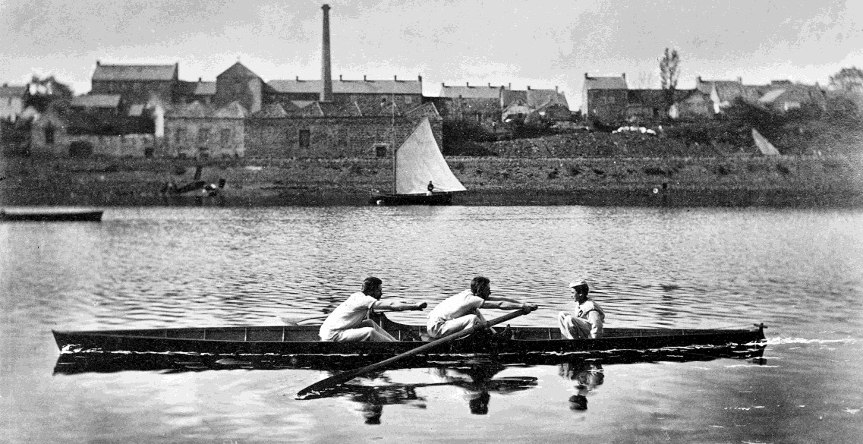

Strand Road and The Champions of the Bann, circa 1864
From the Geoffrey Bevington Collection courtesy of Annabelle Price held by Coleraine Museum

The first recorded victory of the BRC was inscribed on the Richardson Cup in 1842 as, ‘Presented to the Coleraine Rowing Club by Henry Richardson, Esqur., July 1842’. The next recorded victory is accorded to G.M. Knox and R. Kyle Knox and their coxswain Frank Macauley. That was in 1864 when they won the Principal Pair-Oar Race at the Enniskillen Regatta and again that same year in Coleraine. The following year they repeated the victory as seniors at the Belfast Regatta. R. Kyle Knox featured in the BRC victories up until the year 1868. That was also the year Mat Scott from Newcastle was the club trainer.

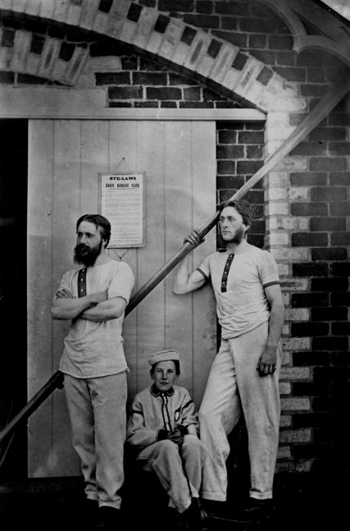
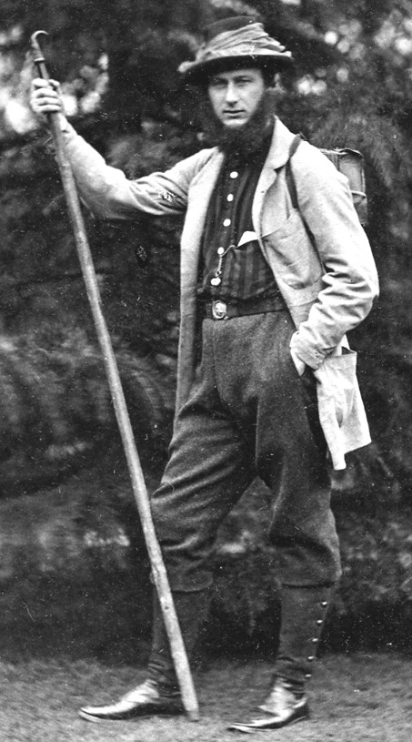

The Champions of the Bann Blundell McCalmont
From the Geoffrey Bevington Collection courtesy of Annabelle Price held by Coleraine Museum
For two decades before and two after the Great War, the names of Thomas Glenn, H.B. Gribbon, J Lowry, J Perry along with David and G. Christie featured prominently in the winning team lists.

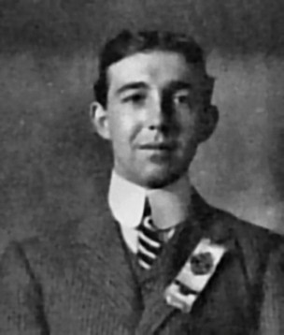
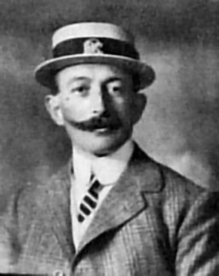

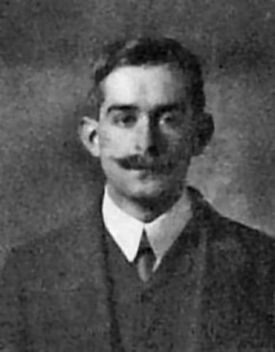

David G. Christie Franklin H. B. Gribbon

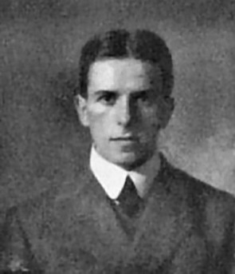
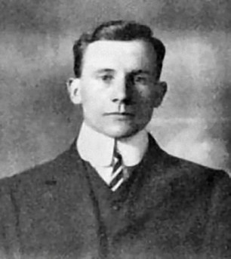

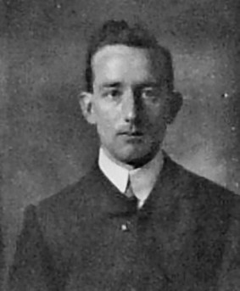

John Lowry J. Perry T. Glenn
Photos courtesy of the Gribbon family.

Tommy Glenn was the outstanding coxswain in those early years. He won his first boat race in 1893
with Joe Irwin’s crew (including McKillop, Moore and Henry). Altogether Tommy took part in 218

victories between the years 1892 and 1937. Joe Irwin owned the corn mill near the present railway station. He married into the Gribbon family of Holme Lea.

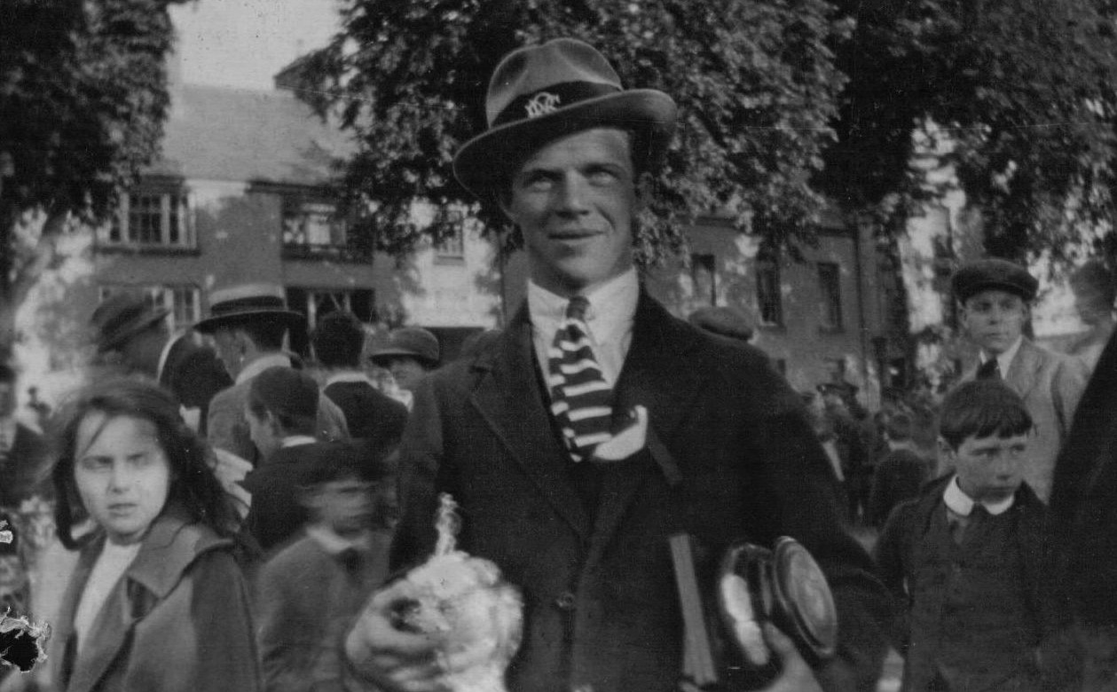

Jim Crawford in Bann Rowing Club colours at the 1921 Bann Regatta
Photo courtesy of Randall Crawford

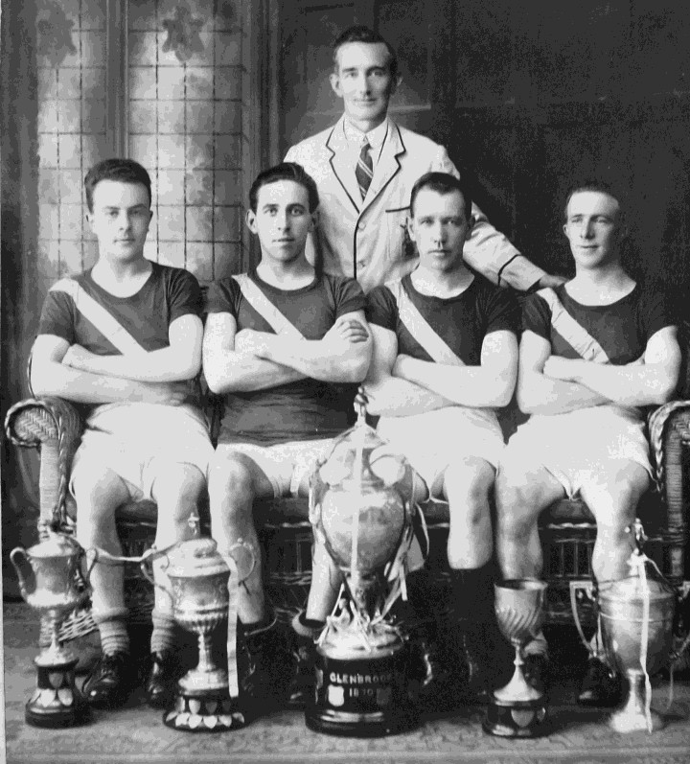

Bann Rowing Club Second Senior Fours, Winners of the Lady Elizabeth Cup, 1924
Jack Wilson, Danny McDowell, Tom Glenn (Cox) John Leonard, William Crawford

The brothers Willie and Jim Crawford both qualified for their place as one of the best eights in the history of the Bann Rowing Club. The crew was Willie Crawford (bow), Jim Crawford, Johnnie McDowell, Johnnie Leonard, Danny McDowell, Moody Love, Jim Neely, Jim Daly and Tommy

Glenn (cox). At the Bann Regatta in 1924 they beat the City of Derry Rowing Club to win the greatest prize in Irish Amateur Rowing, the Union Cup, also known as the Blue Riband of Ireland.

1926 Regattas at Coleraine and Galway

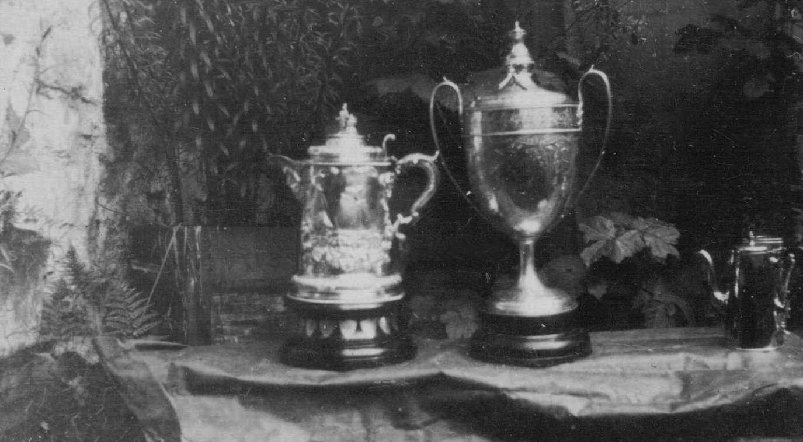

The Bann Cup and The Coleraine Cup
Courtesy of Randall Crawford

In 1926 the Bann Rowing Club had another good year where the Senior Eights won the Coleraine Cup and the Senior Fours won the Coleraine Cup and also went to Galway to win the Galway Cup. This was the first time the BRC had visited Galway.

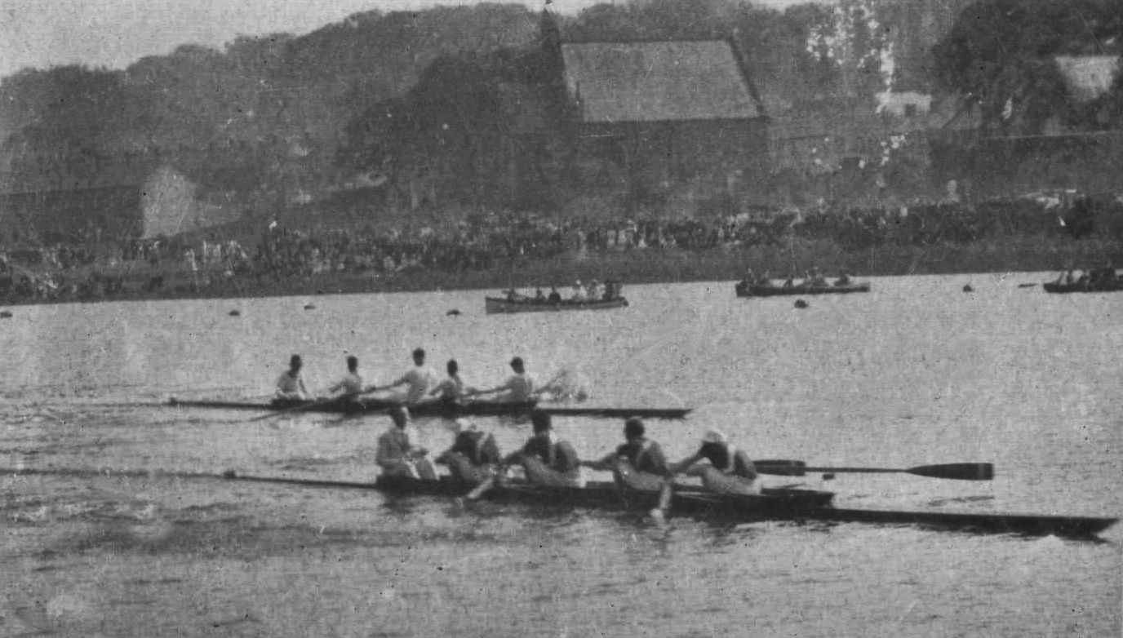

BRC Senior Fours winning against Galway at the Coleraine Regatta in 1926
T. Glenn (Cox), J Crawford (Stroke), J McDowell, D. McDowell and W. Cameron
Photo courtesy of Randall Crawford

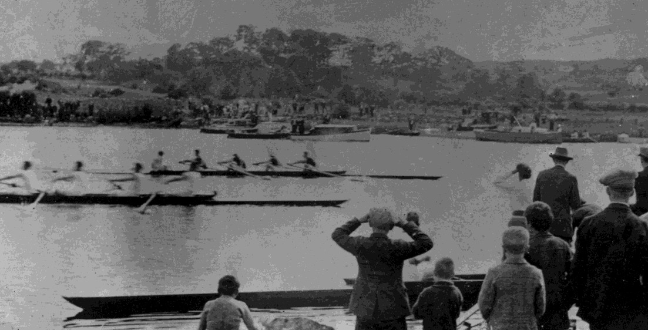

BRC Senior Fours winning at Galway, 1926
T. Glenn (Cox), J Crawford (Stroke), J McDowell, D. McDowell and W. Cameron
Photo courtesy of Randall Crawford

Willie Crawford was also the goalkeeper for Coleraine Olympic Football club in 1927 when they beat Bangor Reserves in the Irish Junior Cup final. Before the rules were changed at least five players from Coleraine Olympic, including some of the Crawford boys left the club and joined Coleraine Rangers. Around that time both Olympic and Rangers won the Irish junior Cup. That year, the BRC coach was the world sculling champion, Bert Barry.

When Johnny Leonard left school, he served an apprenticeship at Gribbon’s Weaving Factory. When the Great War started, like many Coleraine men, he joined The Derrys (10th Battalion, Inniskilling Fusiliers). He attained the rank of sergeant and saw action throughout France including The Somme. At the end of the Great War he returned to Coleraine and established his business as a photographer from that time until he retired in approximately 1959.

Concurrent to his time as a photographer, he was an active and successful member of the BRC, a Captain of Second Coleraine Company of the Boy’s Brigade, a founder member of the Old Boys’ Silver Band, an elder, choir member, a Sunday school teacher, a probation officer and a coach to the BRC and Coleraine Academical Institution.

During the Second World War he was a member of the Home Guard and an officer in the A.R.P. Johnny died in March 1969 aged 76.

